67th Annual Apple Blossom Invitational

OVERALL CHAMPION
Mark Pothier – Ken-Wo
68, 72 = 140

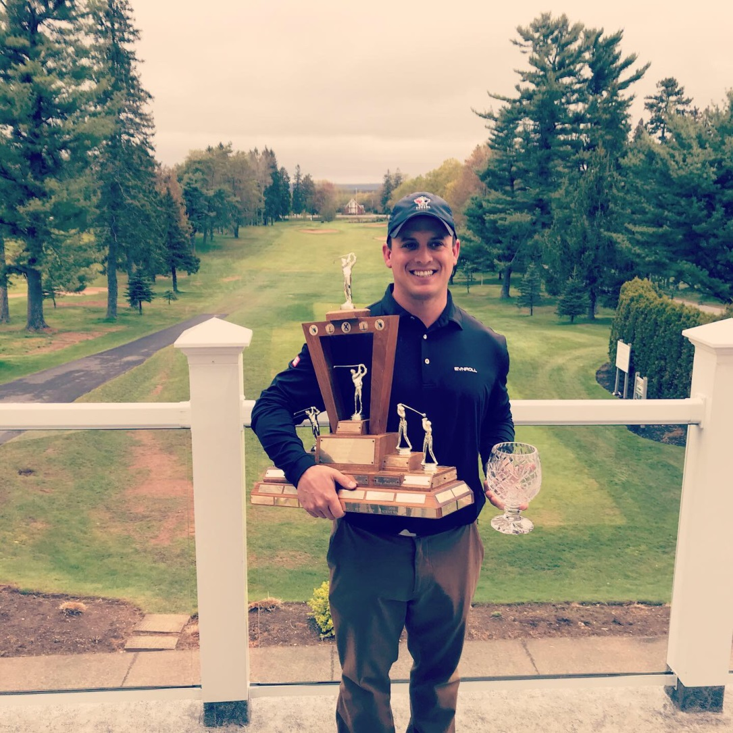

It was another stellar tournament with a star studded field! The 67th Apple Blossom Champion was tied at the top after round 1 and battled through a cold, rainy spring day to capture the title by a single stroke. Congrats to Mark Pothier, the 2019 Apple Blossom Champion!

SENIOR CHAMPION
Steve Ward, Ken-Wo
73,73 = 146

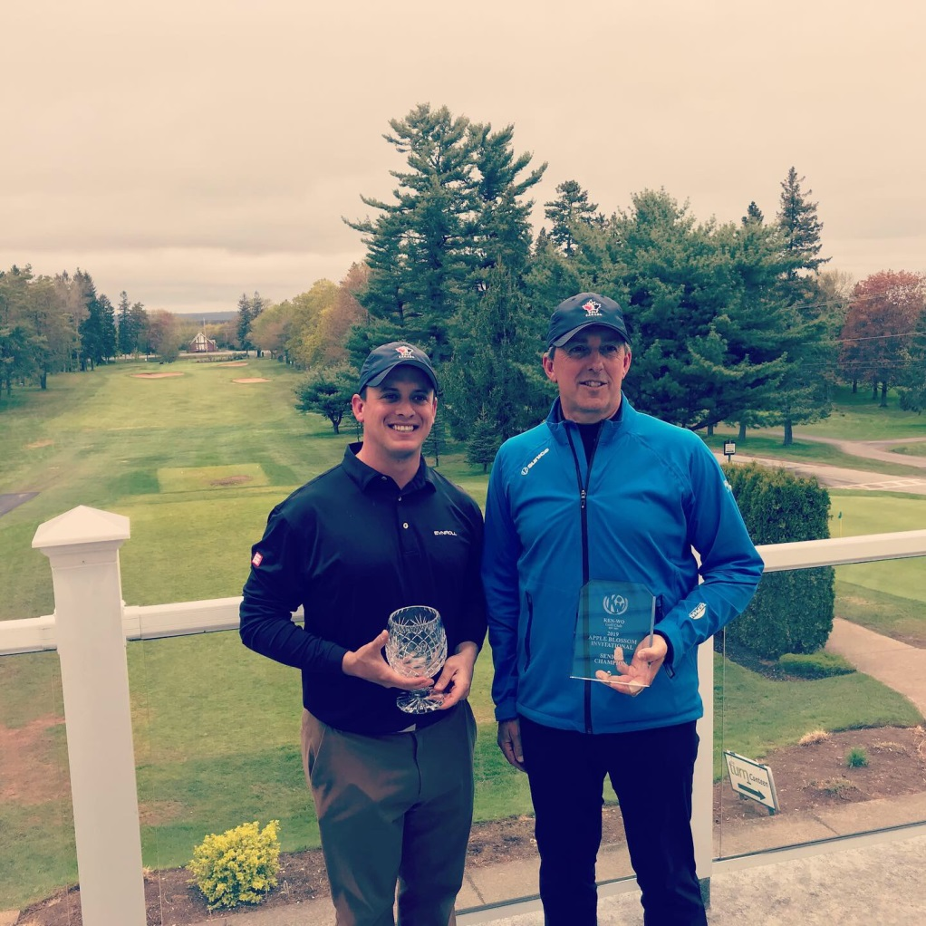

FIRST DIVISION

First Gross Sean Stuart, Ashburn 141
Second Gross Ewan Kelly, Ashburn 141
Third Gross David Williamson, Ashburn 142
Fourth Gross Fenwick Zwicker, Ken-Wo 142
Fifth Gross Bobby Marriot, Granite Springs 142

SECOND DIVISION

First Gross Corey Marcotte, Paragon 141
Second Gross Mark Chandler, Chester 144
Third Gross Braham Leslie, Eagle Crest 147
Fourth Gross Mitchell Campbell, Oakfield 148
Fifth Gross Dave Reid, Ken-Wo 148

THIRD DIVISION

First Gross Cameron Waugh, Oakfield 147
Second Gross Brandyn Ross, Avon Valley 150
Third Gross Terry Moore, Links at Penn Hills 150
Fourth Gross Tyler Ferdinand, Ken-Wo 150
Fifth Gross Matt Collins, NSPP 150

SENIOR DIVISION 1,2,3

First Gross Jeff Hovell, Ashburn 146
Second Gross Dean Woodman, Avon Valley 147

FOURTH DIVISION

First Gross Ed Dumeah, Osprey Ridge 149
Second Gross Derek Bent, Paragon 151
Third Gross Steve Healy Jr., Ken-Wo 152
Fourth Gross Lee Chaulk, Ashburn 156
Fifth Gross Tom McDonell, Oakfield 157

FIFTH DIVISION

First Gross Matt Brophy, Brightwood 149
Second Gross Adrian de Graaf, Ken-Wo 153
Third Gross Dan Gaudet, Oakfield 162

First Net Rick Gray, Ken-Wo 141net
Second Net Ryan Trimper, Ken-Wo 142net
Third Net Kenny MacAulay, Ken-Wo 142net

SIXTH DIVISION

First Gross Mason Cook, Brightwood 155
Second Gross Colin Muise, Paragon 165
Third Gross Ewan Kelly Sr., Ashburn 167

First Net Dean Aza, Avon Valley 135net
Second Net Andrew Burnet, Ken-Wo 140net
Third Net Stu Ellsworth, Ken-Wo 142net

SENIOR DIVISION 4, 5, 6

First Gross Sandy Herrick, Paragon 163
Second Gross Drew Maclean, Digby Pines 164

First Net Jake Leyte, Granite Springs 144net
Second Net Chirs Hopgood, Ashburn 144net

CLOSEST TO THE HOLE

Day 1:

#2 Bobby Marriott 30inches
#5 Trevor Show 73 inches
#11 Mitch Campbell 13.5 inches
#13 Corey Marcotte 22.5 inches
#15 Corey Marcotte 12 inches
#8b Sandy Herrick Hole in One!

Day 2:

#2 Murray Carruthers 69 inches
#5 Sean Stuart 67 inches
#11 Chad MacMillan 105 inches
#13 Adrian de Graaf 36 inches
#15 Fred Rogers 80 inches
#8b Brandon Cuvelier 10 inches

RANGS:

Day 1 - Div. 4, 5, 6

#4 Dean Aza
#5 Justin Martin
#9 Kenny MacAulay
#8b /16 HOLE IN ONE! Sandy Herrick
#18 Ian MacLeod

Day 2 – Div. 4, 5, 6

#3 Adrian de Graaf
#8 Sam Kenny
#10 Ben Smith
#12 Andy Burnet
#17 Mason Cook

Day 1 - Div. 1, 2, 3

#1 Charlie Doran
#3 Terry Clarke
#4 Mark Metcalfe

Day 2 - Div. 1, 2, 3

#2 Matt Chandler
#4 Brandon Cuvelier
#7 Calum Cummings
#9 Dave Reid

